Feedback about chatbot

1. The response text boxes are not using the same attribute. For example, the email input and phone number input are using the different attributes than the others

The others:

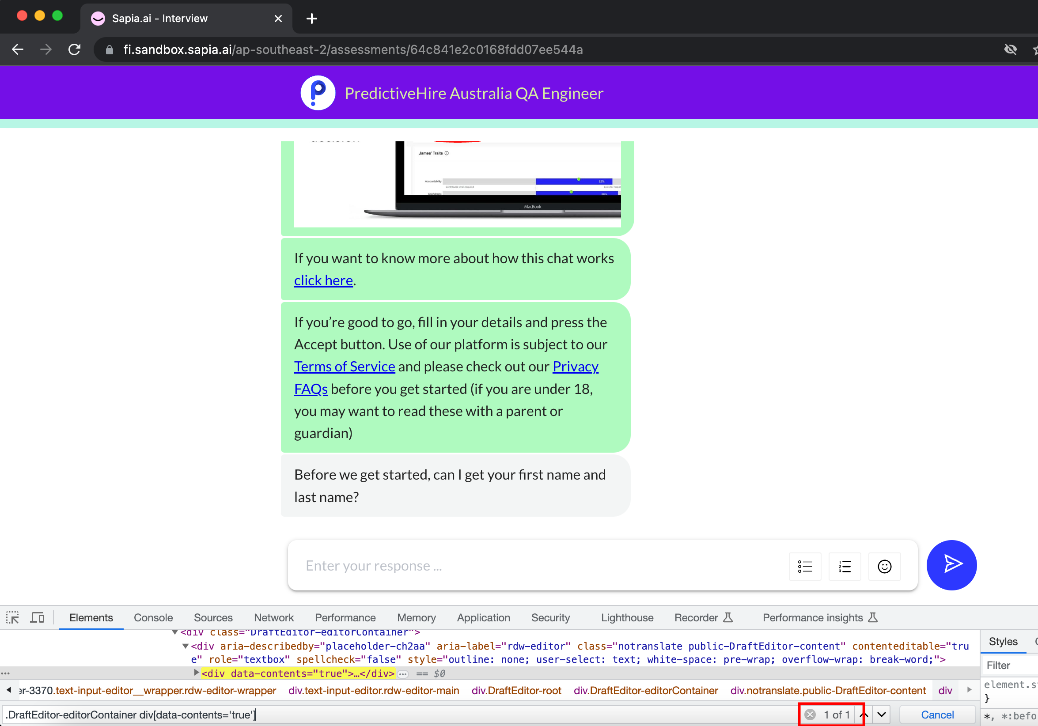

Emai and Phone number:

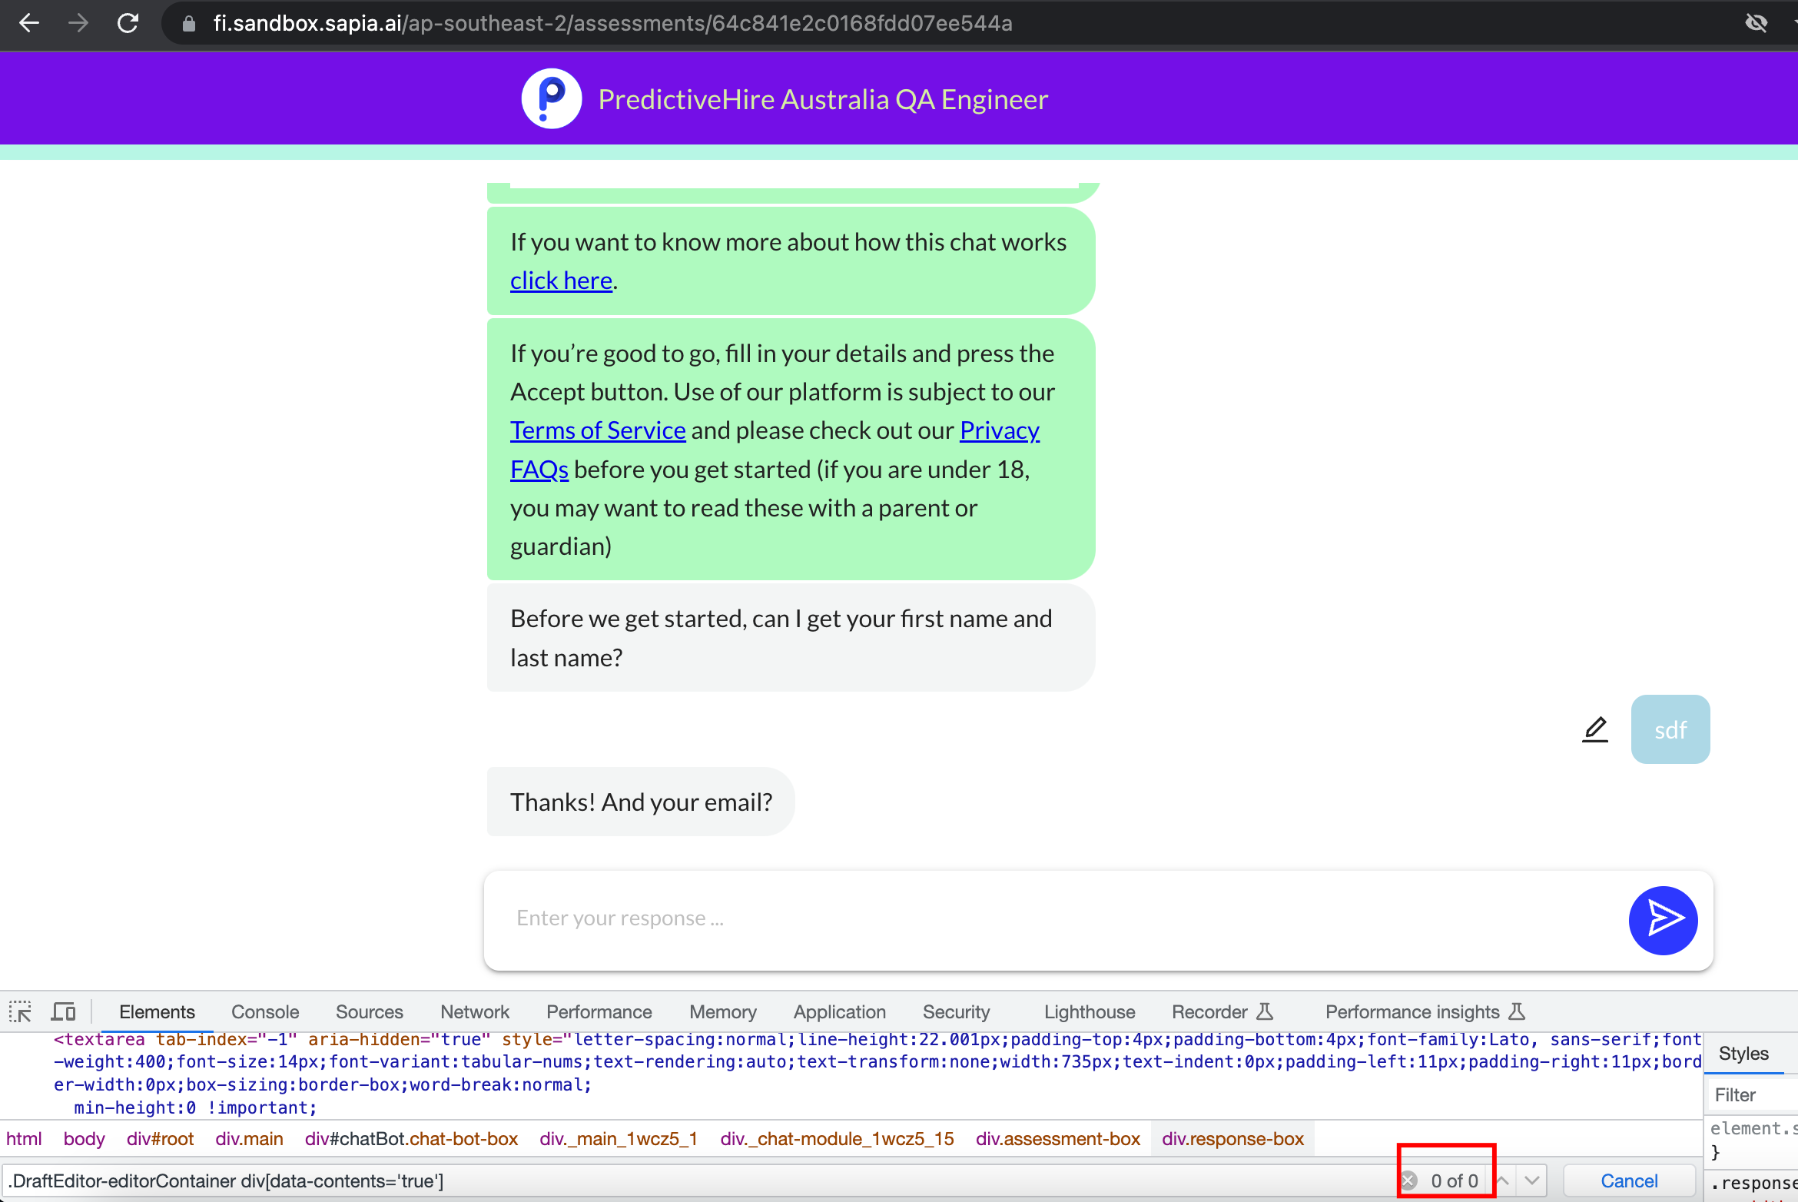

1. The Error dialog about less than 50 words is not using the fixed ID attribute, sometimes it uses **rcDialogTitle0** or **rcDialogTitle1** or **rcDialogTitle3**

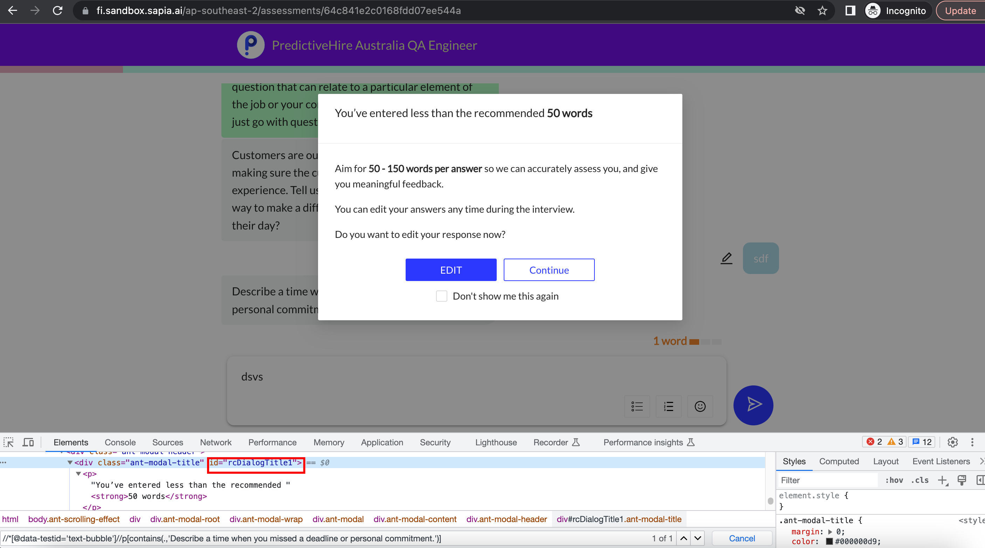

1. End users can not edit the answers or add more additional information after they submitted the interview
2. End users can not review their answers again if they finished the Chat Interview
3. The Copy-Paste on Desktop browser and mobile browser are not consistent: Users are not allowed to copy or paste on Desktop browser but they can do these actions on mobile browser